Automation on Verification of SVN Backup Restoration

Submitted By

Ramesh Bhaabu VS Jayganesh Sambath

1. Introduction 3
1.1 Purpose / Objective 3
1.2 Scope 3
1.3 Project Used/ Implemented 3
1.4 Contact Information 3
1.5 Technology Used 3
2 Definitions, Acronyms and Abbreviations 3
3 Problem Definition 4
4 Proposed Solution 4
4.1 Solution Architecture 4
4.1 Configuration 7
It is a stand-alone application comprising of a single executable file; we can run the tool just by double clicking it. 7
4.2 Code Snippets 11
5 Limitations of the Solution 13
6 Benefits 13
7 Challenges Encountered 13
8 Areas for Improvement 14
9 References 14

- Introduction

Purpose / Objective
The purpose of this document is to record in detail the technical aspects of the solution provided to manually doing the verification of Backup restoration process of an SVN Repository.
-The manual work of doing the verification process is automated to save time and efforts.
- The automated solution assures 100% quality of verification.

Scope
This documentation is intended for Configuration Librarians (CLs) or any team members who want to verify their Project Repository's backup version. This tool can only be used for source code maintained in SVN source control.

Project Used/ Implemented
Some of the projects in Thomson Elite account:
- TE – EPM
- TE – ENTERPRISE
- TE – SCM
- TE – Image Connect
- TE – Webview
- TE – CAT

Contact Information
Jayganesh Sambath – Jayganesh.sambath@csscorp.com
Ramesh Bhaabu VS – rameshbhaabu.subramanian@csscorp.com

Technology Used
- SVN
- PowerShell 2.0
- .NET Framework 4.0
- C#

Definitions, Acronyms and Abbreviations

Acronym | Definition/Expansion
SVN | Subversion (SVN) is a software versioning and revision control system distributed under an open source license.
Backup | Copying and archiving the server data.
Restoration | The process of replacing old file with original one (usually with a backed up copy).
VisualSVN Server | VisualSVN Server is a free Apache Subversion server package for Windows.
Repository | A repository serves as the core storage mechanism for Subversion's versioned data.
Checkout | Copying the server file to local.
Pre-Requisites | Basic mandatory requirements

Problem Definition
Currently Configuration Librarians (CLs) of CSS Application Services (AS) Projects have to verify if the Backups of their Project repositories are done properly. To perform the task, they have a practice called “Backup & Restoration Verification process”. This process involves the below steps:
- As per the defined frequency (3/ 6 months) in CMP, a CL requests Backup copy of his/ her project repository. On receiving the request, IT team will take the backup copy and restore it in a SVN server that will be accessible to CL.
- IT team will notify CL the URL of the Backup restored URL.
- CL has to manually verify the Backup restored SVN repository with his/ her live repository.
- After verification they need to prepare a report for the verification process.

By doing manually, CLs can’t be able to check all the files and folders. Also, they can’t be 100% sure that all the backed up files & folders are intact. Also, this task would take more time and efforts.

Proposed Solution
- To overcome the difficulties of doing the manual verification, we have automated the verification process.
- “EasySVNdiff” is a simple solution which will automatically find the differences between live repository and restored-backup repository.
- Reports generated from “EasySVNdiff” will have more details which will be very useful for documentation and further references.

4.1 Solution Architecture
Architecture of EasySVNdiff comprises three layers:
- Presentation
- Business Logic
- Server logic

- Presentation:
This layer denotes the User Interface provided for getting required inputs. C# WinForms have been used for this purpose.
- Business Logic:
This layer denotes the business logic required to validate the user inputs and screen navigations. Also includes the detailed log file creation and HTML report generation. Particularly, the check-out process has been implemented asynchronously using C# Lambda expressions.

- Server Logic:
This layer denotes the backend operations such as connecting to SVN server, creating temporary user, repositories, checking out files and doing comparison. This logic has been written using WMI, Windows Powershell and C# Process objects.

Process flow:

“EasySVNdiff” will get the required details from the user and based on the user credentials it will checkout the files (which need to be compared) from Live and Backup-Restored repository. Then it will import the files to local VisualSVN server temporarily. Now the files are ready to compare. Logic in the tool will compare each and every file in the local folder and it will generate the report with all required details. Once the process is completed, it will remove all the temporarily used folders automatically.

“EasySVNdiff” work-flow steps:

- Download files from Live SVN repository.
- Download files from Backup-Restored SVN repository.
- Import Live SVN repository files to local SVN repository.
- Import Backup-Restored SVN repository files to local SVN repository.
- Find the differences
- Generate the verification Reports in HTML format.

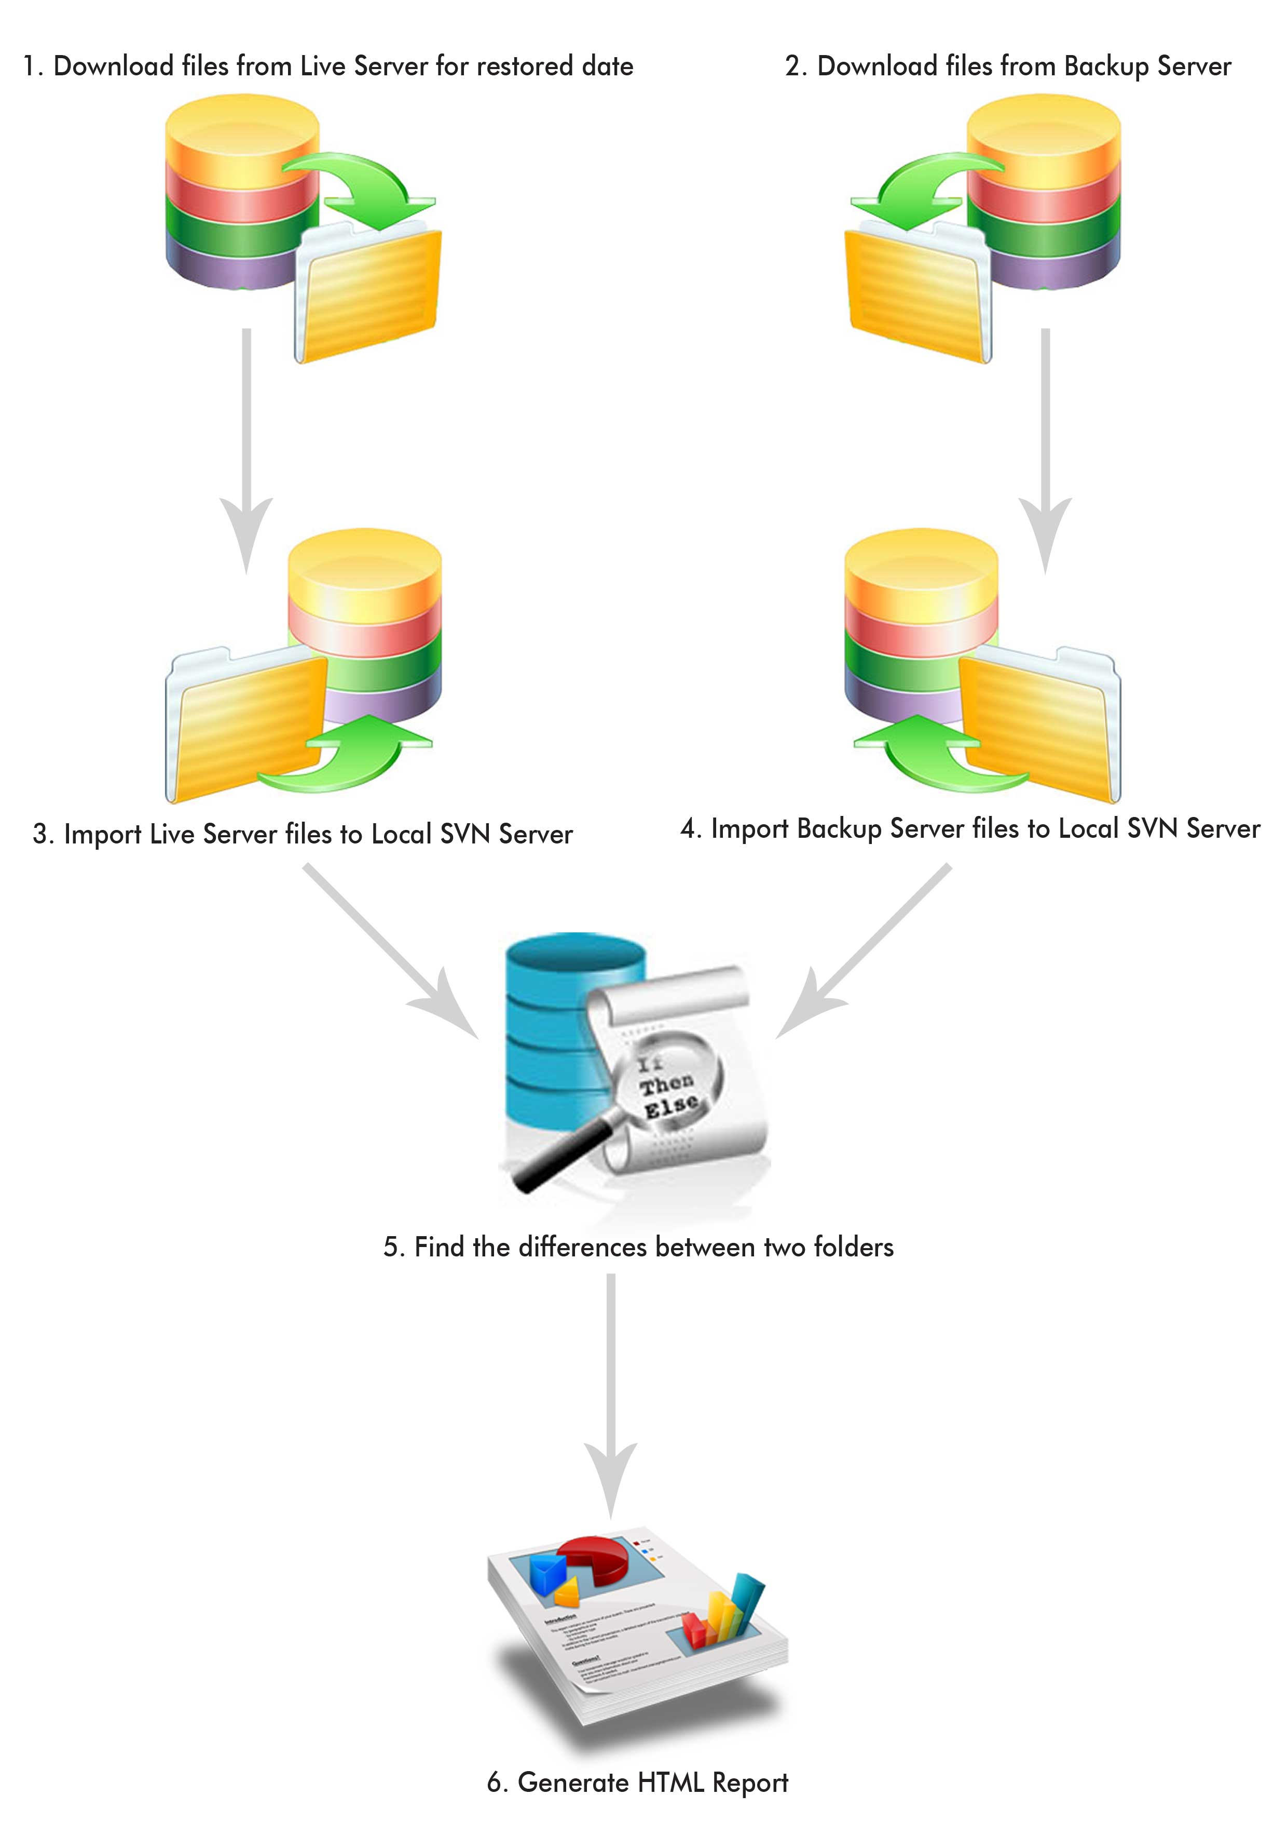

Configuration

It is a stand-alone application comprising of a single executable file; we can run the tool just by double clicking it.

Process Flow:

Step 1: Pre-Requisites

- In this Pre-requisites screen, it will check whether the required software already installed in the system.
- If any software is not available, then that particular software name will be displayed in Red color Hyperlink.
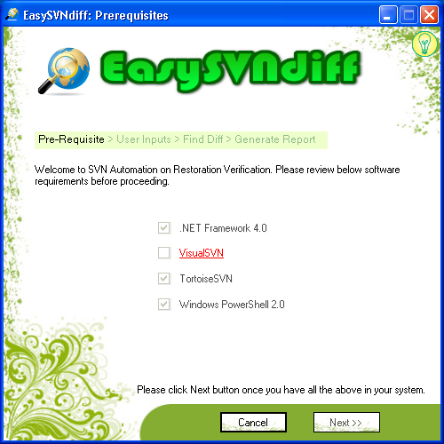
- By clicking the hyperlink, it will navigate to the web page to download the missing software.

Step 2: User Inputs

- In this screen, the tool will get the required information from the user like Username, Password, etc of both the repositories – Live & Backup restored.
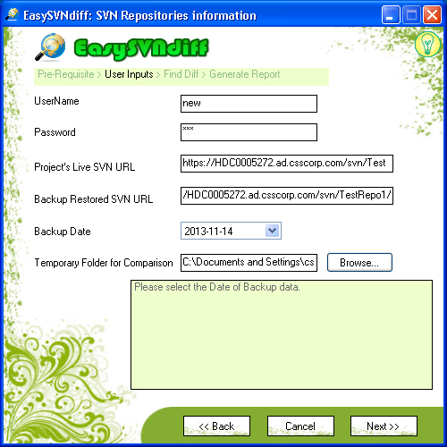
- It will validate all the fields and it will prompt the user if any field has invalid details

Step 3: Find the Differences

- While clicking the Next button in the previous screen, it will navigate to this screen and start comparing the files. This screen will display the process log.
- If any repository is empty it will prompt the user with repository details and go to previous screen.
- After successful comparison clicking “Get HTML Report”, it will generate the HTML report with required details
- While clicking “Done” it will end the process.
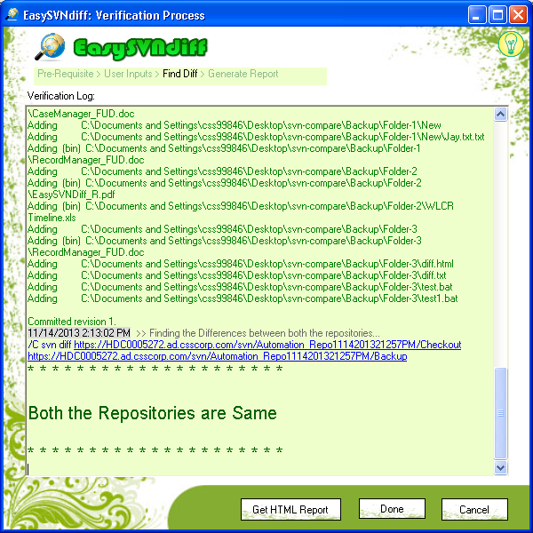
- If we want to cancel the operation during file comparison, we can click Cancel button to stop the process.

Step 4: Generate Report

- After clicking Get HTML Report button, tool will require some project specific details from user for the purpose of displaying in the HTML report.
- It is possible to save the detailed log to a text file by enabling the check box provided for it. By default, it will be checked.
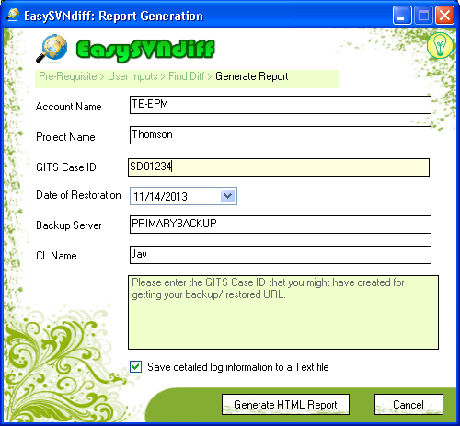

Step 5: Save the Report
- Final step; HTML report is generated successfully.

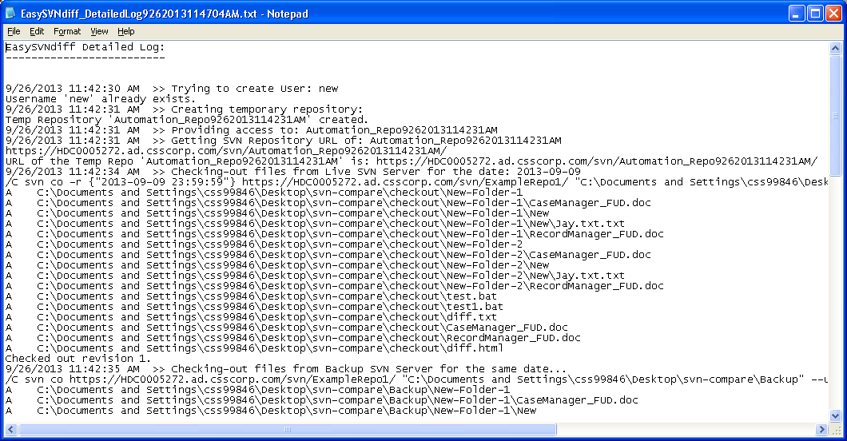

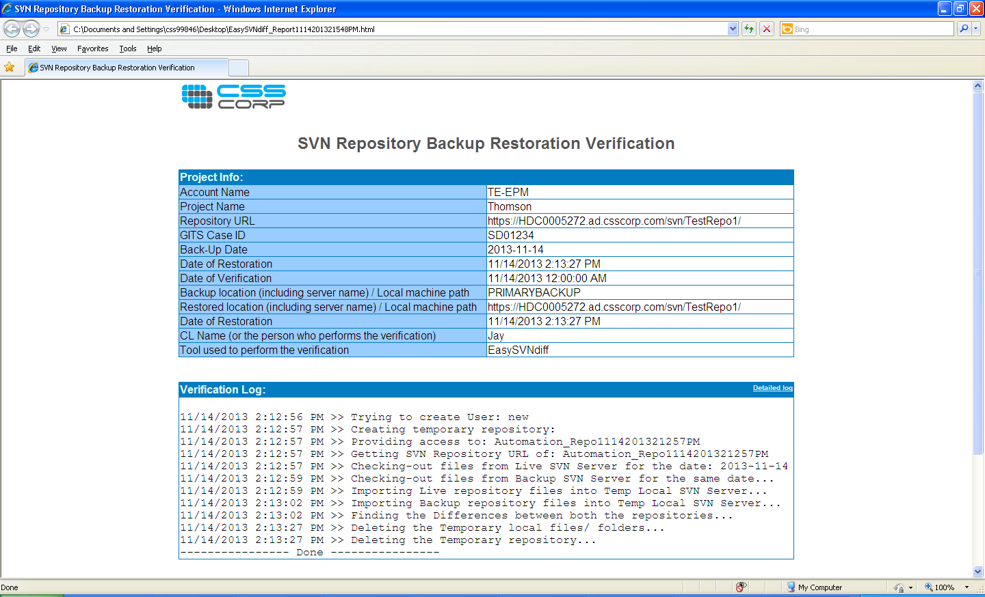

Code Snippets

SVN commands used in the tool:

svn checkout -r {"2013-09-09 23:59:59"} <live_svn_url> <local_path> --username <user_name> --password <password>
Code-1: Sample code to checkout live Repository for particular date

svn import --message "Import live server files to local server" <local_path> <local_svn_reposotory_live_folder_url>
Code-2: Sample code to import live repository file to local SVN repository

svn diff <local_svn_reposotory_live_folder_url> <local_svn_reposotory _backup_folder_url>
Code-3: Sample code to find the difference between two folders

System.Diagnostics.Process chkLog = new System.Diagnostics.Process();
System.Diagnostics.ProcessStartInfo startchkLog = new System.Diagnostics.ProcessStartInfo();
startchkLog.CreateNoWindow = true;
startchkLog.WindowStyle = System.Diagnostics.ProcessWindowStyle.Hidden;
startchkLog.FileName = "cmd.exe";
startchkLog.Arguments = "/C svn list \"" + LiveURL.Trim() + "\" --username " + UserName.Trim() + " --password " + Password.Trim();
chkLog.StartInfo = startchkLog;
chkLog.StartInfo.RedirectStandardOutput = true;
chkLog.StartInfo.RedirectStandardError = true;
chkLog.StartInfo.UseShellExecute = false;
chkLog.Start();
Code-4: Sample Code snippet to execute an SVN command using C#

ManagementClass userClass = new ManagementClass("root\\VisualSVN", "VisualSVN_User", null);
// Obtain in-parameters for the method
ManagementBaseObject inParams = userClass.GetMethodParameters("Create");
// Add the input parameters.
inParams["Name"] = UserName;
inParams["Password"] = Password;

// Execute the method and obtain the return values.
ManagementBaseObject outParams = userClass.InvokeMethod("Create", inParams, null);
Code-5: Sample Code snippet to execute an SVN command using C# & WMI

System.Diagnostics.Process getURL = new System.Diagnostics.Process();
System.Diagnostics.ProcessStartInfo startGetURL = new System.Diagnostics.ProcessStartInfo();
startGetURL.CreateNoWindow = true;
startGetURL.WindowStyle = System.Diagnostics.ProcessWindowStyle.Hidden;
startGetURL.FileName = "cmd.exe";
startGetURL.Arguments = "/c powershell -Command \"& { Get-WmiObject -namespace root\\VisualSVN -class VisualSVN_Repository | Select-Object -expandproperty URL | Select-String -SimpleMatch \"" + RepoName + "\"}\"";
getURL.StartInfo = startGetURL;

getURL.StartInfo.RedirectStandardOutput = true;
getURL.StartInfo.UseShellExecute = false;
getURL.Start();
Code-5: Sample Code snippet to execute SVN command using PowerShell

Limitations of the Solution

As we mentioned earlier, this tool can only be used to compare repositories in SVN. It will not support other SCM tools than SVN.

Benefits
- The manual work of doing the verification process will take an average of 2 Man hours but this tool will require over all 5 - 10 minutes of efforts to input the tool with required details.
- The automated solution assures 100% of guaranteed verification.
- Ease of use.
- Intuitive UI.
- No dependencies to run the tool other than what a CL has to have in his/ her machine.
- Detailed log on whatever the tool does to compare the repositories. This includes the SVN commands that the tool used to execute.

Challenges Encountered
- The command “svn diff” is only used to compare two folders in same repository, so we had created the local SVN repository, then given access to that repository and get the URL for that repository.
- Validate for installed software in local machine had done in “Pre-Requisites” screen

Areas for Improvement
We have implemented the core logic for comparing the SVN repositories. This tool can be further enhanced to handle more other needs that will arise during the course of time. In similar manner, we can also create tools for other SCM tools.

References
- http://www.linuxfromscratch.org/blfs/edguide/chapter03.html
- http://msdn.microsoft.com/en-us/library/aa393964%28v=VS.85%29.aspx

